Google Chrome Users
Certain browser settings in Google Chrome can prevent a user from successfully logging in to the chapter site through single sign on. To find which browser versions are currently supported by PMI and check which version you are currently using, please go to: http://www.pmi.org/About-Us/Browser-Support.aspx.
To ensure the appropriate settings for third party cookies and Javascript are set for your browser, please follow the steps below:
- Click the Chrome menu icon on the browser toolbar.
- Select Settings.
- Click Show advanced settings near the bottom of the page.
- Click Content settings in the Privacy section.
- In the Cookies section, select Allow local data to be set to allow both first-party and third-party cookies. Make sure the box next to Block all third-party cookies without exception is unchecked.
- In the JavaScript section, select Allow all sites to run JavaScript (recommended).
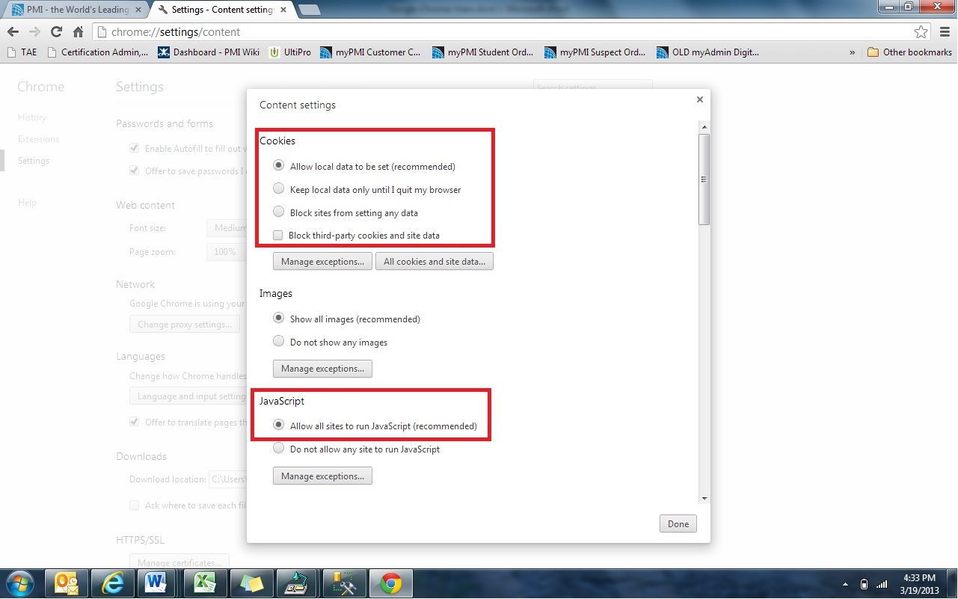
If the settings above are correct and you are unable to login, please try the following steps to delete cookies. If you do not want to remove all cookies, you can delete the specific cookies associated with single sign on.
Click the Chrome menu on the browser toolbar.
- Select Settings.
- Click Show advanced settings.
- In the Privacy section, click the Content settings button.
- In the Cookies section, you can change the following cookies settings:
  - Click All cookies and site data to open the Cookies and Other Data dialog.
  - To delete all cookies, click Remove all at the top of the dialog.
  - If you do not want to remove all cookies, you can delete the cookies associated with gigya.com, pmi.org, and the chapter site. To delete a specific cookie, search for the site that issued the cookie, then select the cookie and click X. In this case, search for the DOMAIN NAME i.e. Gigya.com, pmi.org, and the chapter site’s domain. Any entries that show during the search should be removed.
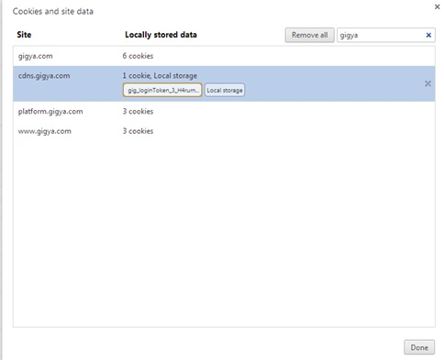
- After deleting the cookies, click Done.
- Close the browser and any other browser window that may be open.
- Open a new browser session and attempt to login to the chapter site.

