Internet Explorer Users
Certain browser settings in Internet Explorer can prevent a user from successfully logging in to the chapter site through single sign on. To find which browser versions are currently supported by PMI and check which version you are currently using, please go to: http://www.pmi.org/About-Us/Browser-Support.aspx.
To ensure the appropriate settings for third party cookies and Javascript are set for your browser, please follow the steps below: ***Please Note*** If you are using a corporate managed computer, some of these settings may be locked and thus can only be changed by your corporate IT department. In such a case, you can try a different computer that is not corporately managed or work with your IT department to have the requested changes implemented.
Enable JavaScript
- From the Internet Explorer browser menu, select Tools and then select Internet Options.
    - Please note that for Internet Explorer versions 9 or higher, the Tools menu is found in the menu bar as an ICON of a GEAR 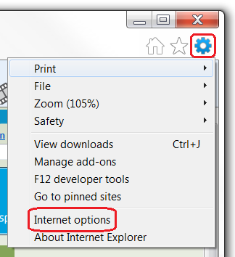
- In the Internet Options window, select the Security tab.
- Under the Select a zone to view or change security settings, select Internet.
- On the Security tab, click on the Custom level... button.
- When the Security Settings - Internet Zone dialog window opens, look for the Scripting section.
- In the Active Scripting, be sure that the option Enable is selected.
- If it is not selected, select it.
- When the Warning! window pops out asking "Are you sure you want to change the settings for this zone?" select Yes.
- In the Internet Options window, click on the OK button to close it.
- Click on the Refresh button of the web browser to refresh the page.

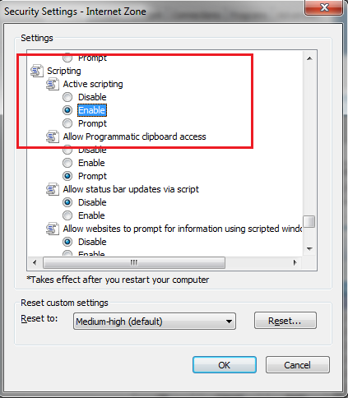
If the settings above are correct and you are unable to login, please try the following steps to delete cookies.
- To delete cookies, go to the Tools Menu and choose Internet Options.
- Under Browsing History, click on the Delete button.

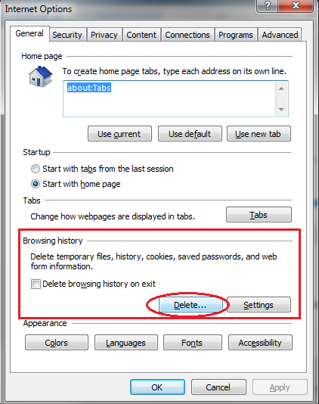
- Only the options for Temporary Internet files and Cookies need to be selected.
- Click Delete button.
- Click Okay.
- Close the browser and any other browser window that may be open.
- Open a new browser session and attempt to login to the chapter site.

