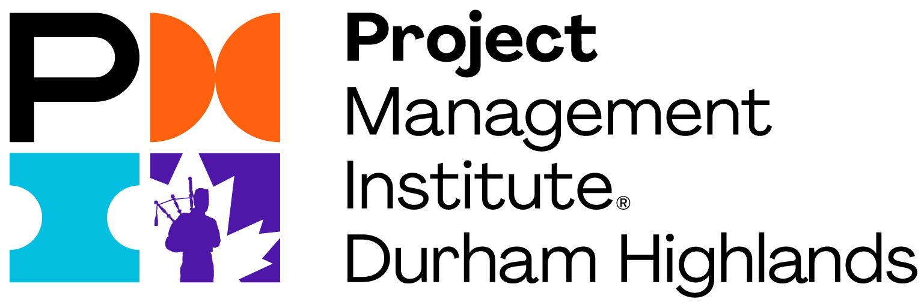
PROFESSIONAL DEVELOPMENT EVENTS

SPEAKER PRESENTATION FORM

Virtual Zoom Delivery
Thank you for expressing interest in volunteering your time to speak at one of our Professional Development
(PD) Events.

ABOUT PMI DURHAM HIGHLANDS’ PD Events
PMI Durham Highlands Chapter (PMI-DHC) is a non-profit chartered chapter of the Project Management Institute (PMI), and is dedicated to advancing project management in the Durham region and surrounding areas. We are continuously seeking keynote speakers for our PD events willing to donate their time to enrich the knowledge of our membership in areas of the PMI Talent Triangle®: 1) Ways of Working, 2) Power Skills, and
3) Business Acumen.
PMI-DHC PD events are held Saturday mornings or weekday evenings. The vast majority of attendees are PMP® certified, though some are Project Management students, while others are CAPM® certified or do not hold a PMI designation.
As part of our advertising process, a summary of upcoming Events is posted on the PMI-DHC website http://pmi-dhc.ca/meetinginfo.php.

SUBMISSION REQUIREMENTS
- You may provide multiple submissions.
- Each submission must be for a specific topic and fall within the PMI Talent Triangle® (see above).
- The PMI-DHC reserves the right to accept or reject any submission.
- Your presentation shall not be a sales pitch for any specific product or service but rather informative and/or educational.
- Speakers certify that their presentations are unique material, and that they have the legal rights to deliver the presentation.

INSTRUCTIONS FOR SUBMISSION
Please complete all sections of this form and return it, in current format, to be considered for a speaking opportunity. Upon agreed schedule and details of speaker and presentation information, the contents will be used for event information on our website, emails sent to our membership, and social media posts to market the event, and you as a keynote speaker.
Email your completed submission (form and photo) to: education@pmi-dhc.ca

SPEAKER INFORMATION (* = mandatory requirements)
*NAME
*DESIGNATION(S): |  | *EMAIL:
*MOBILE PHONE #: |  | OTHER PHONE #:
Website: |  | Blog:
Youtube: |  | LinkedIn:
Instagram: |  | Twitter:
*SPEAKER BIO:
Please write in 3rd person and max 200 words.
Your bio can include your PM experience, subject matter expertise, qualifications, position, employment background, industry involvement, personal interests/hobbies)
Speaker Video:
A video is worth a million words. If you also have a short video, we could use to market your presentation, please provide the link.
*SPEAKER PHOTO: Please include at least one photo (headshot) of yourself from the chest up as part of this submission.
Specifications: Colour, 1200x1200 pixels @ 72dpi and in one of the following formats: png, jpg or pdf.

PRESENTATION INFORMATION (* = mandatory requirements)
*FORMAT:  Describe your event, i.e., workshop, presentation, other. |  |  |  | *ESTIMATED TIME FOR DELIVERY:  Between 1.5 to 4 hours.
*TITLE:
Max 75 characters with spaces. Shorter is best.
A statement or a question to attract audience.
*SYNOPSIS:
Max 300 words including Key learnings / Take-aways.
Provide a brief description of your topic outlining the key concepts and specific key learnings.
*Key learnings / Take-aways:
Please list 2 to 5.
Requirements:
List any requirements or preferences you have for your presentation.
*SUBMISSION: On agreement of assigned PD Event, please submit your final presentation and any complementary
materials no later than 10 days pre-event.
Specifications: Presentation to be supplied in both MS PowerPoint and PDF.
Complementary materials to be supplied in PDF only.
*TO BE COMPLETED BY PMI-DHC |  | #PDUs
Talent Triangle:  List Professional Development Units (PDUs) for this event. | Ways of Working
 | Power Skills
 | Business Acumen

MEETING INFORMATION (* = mandatory requirements)
*PREFERRED MONTH:  Please list available months for you to present in order of preference from September to June.  Note: various months may already be assigned for the current year (Sept – June) |  | *PREFERRED TIME:  Please list available days in order of preference. Choice includes: Saturday morning, Tuesday, Wednesday, or Thursday evening.  Note: if format is more than two hours in length, event may be split between two days.
LOCATION: | Virtual Zoom Delivery
LOGISTICS: | Logistics call to be scheduled by PMI-DHC in agreement with speaker.
*TO BE COMPLETED BY PMI-DHC
Confirmed Event Date: |  | Logistics Call Date/Time:
Early Bird Cutoff Date/Time: |  | Early Bird Offer:
Price:  Assumption: HST is added.  If HST is included, provide breakdown beside price. | Member | $
 | Non-member | $
 | Student Member | $
 | Student Non-member | $

ACKNOWLEDGEMENTS (* = mandatory requirements)
Presentation: | PowerPoint presentations are typically distributed to registrants at the conclusion of the event. By participating, speakers hereby grant PMI-DHC, and its representatives, permission to distribute your presentation and any complementary materials to all registrants of the event.
Recordings & Photography: | Videos and screenshots are typically captured during PMI-DHC events. By participating, speakers hereby grant PMI-DHC, and its representatives, permission to record/screenshot them at events and distribute (both now and in the future) the speaker's image or voice in photographs, electronic reproductions of such events and activities.
*AGREEMENT & SIGNATURE: | By submitting this form, I affirm that the facts set forth in it are true and complete. I certify that my presentation and any complementary materials is/are unique and that I have the legal rights to present them. I will submit the final presentation/material(s), no later than 10 days pre-event.  I understand that this information will be distributed amongst the PMI-DHC mailing list and posted on the PMI-DHC website. I also understand that my presentation will be distributed to registrants of the event and that participation in the meeting may be recorded/screenshot by PMI-DHC for distribution.
 | *Speaker Name:
 | *Date of Signing:
 | *Signature of Speaker:

